Compassion Resilience Toolkit for School Leaders and Staff

Introduction
The reality of public school education is that it is both exhilarating and stressful. Education is a realm full of organizational and professional changes, expectations, and uncertainties that are often continuous, occurring at an ever-increasing pace, sometimes contradictory, and usually in response to economic, social, and political demands. In our efforts to build resilience in our students, we are charged with the examination of our capacity personally and professionally to model that which we strive to build, and the extent to which our organizational culture and systems support these efforts. An intentional focus on building teacher resilience is both an individual and organizational responsibility and opportunity.

What is Compassion Resilience?
Teacher resilience is a relatively recent area of investigation which provides a way of understanding what enables teachers to persist in the face of challenges and offers a complementary perspective to studies of stress, burnout and attrition (Beltman et al., 2011). Teacher resilience is defined as “using energy productively to achieve school goals and meet students’ needs in the face of adversity” (Patterson et al., 2004). Compassion is the combination of the consciousness of others’ distress and a desire to alleviate it. It is a basic quality needed to be able to meet students’ needs. Compassion resilience for those in the education field is:
- The ability to maintain our physical, emotional and mental well-being (using energy productively) while compassionately identifying and addressing the stressors that are barriers to learning for students,
- Identifying and addressing the barriers to caregivers/parents and colleagues being able to effectively partner on behalf of children, and
- Identifying, preventing, and minimizing compassion fatigue within ourselves.
Think of this resilience as a reservoir of well-being that we can draw upon on difficult days and in difficult situations. It is a dynamic process or outcome that is the result of interaction over time between a person and their environment (e.g., Bobek, 2002; Day, 2008; Sumsion, 2003; Tait, 2008). Resilient teachers tend to maintain job satisfaction and commitment to their profession (Brunetti, 2006). This toolkit will explore the protective factors that build and maintain compassion resilience.
Why Build Resilience in Teachers?
It may seem obvious, but if teachers are depleted, confused, overwhelmed or despairing, how can they possibly engage in professional development focused on curriculum alignment, formative and summative assessments, or other salient teaching practices? Or meet the increasingly complex social and emotional needs of students in today’s classrooms? A focus on compassion resilience will guide teachers back to the core set of values and the drive for a sense of purpose that drew them to teaching in the first place. It will do so by surrounding these drivers with a strong set of skills to manage expectations, set professional and personal boundaries, build effective collegial relationships, and practice real-time and ongoing self-care. Resilient teachers find it easier to focus on student learning, and are able to let go of systemic factors that are beyond their control and influence those that require attention. A focus on relational trust between teachers, students, families, colleagues and administration will encourage the risk taking and exploration of new ideas that promote good teaching and learning. Finally, teachers aren’t the only ones who benefit from a focus on resilience. Principals, administrators, superintendents, student services staff, coaches, para-professionals, and others who form the school community contribute to the decisive elements that influence a school that is thriving.
Compassion Resilience Toolkit for School Leaders and Staff
Outline
Information, activities and reflections for school leadership and staff to understand, assess and build their capacity for consistently compassionate interactions with students, families and colleagues.
Preface
- Introduction
- Implementation Guidance for School Leaders and Toolkit Facilitators
Content Sections
- Rationale for the Compassion Resilience Focus and Approach – Leadership and Staff
- What Are We Talking About?
- Compassion Fatigue Awareness, Connection to Trauma, and Assessments
- Systemic Drivers of Compassion Fatigue
- Expectations from Self and Others
- Compassionate Boundary Setting – Personal and Professional
- Contract for Positive Staff Culture
- Strategies – Mind
- Strategies – Spirit
- Strategies – Strength
- Strategies - Heart
- Compassionate Connections with Parents
Appendix
- Foundational Beliefs about Behavior
- Dealing with Significant Staff Disclosure or Crisis
- Supporting Change Efforts of Others and Ourselves
- Stress throughout the Career Cycle

The Rationale for Compassion Resilience for Staff & Leadership
A growing body of evidence establishes the importance of building and supporting educator resilience particularly in the face of challenging personal, social, emotional, political and organizational demands of the profession. Consider the impact educator resilience and satisfaction (or the lack thereof) have on students first and foremost, as well as on educational organizations and their management:

I. Student Achievement & Educator Resilience:
- Factors including resilience, confidence, persistence, and relational trust are considered competencies of both individual teacher efficacy as well as collective, organizational efficacy, and shown to be valid and reliable predictors of student achievement.
II. Compassion Resilience & Educator/Leader Retention:
- Compassion fatigue is seen in the reduced productivity of staff who are present but unwell, often referred to as “presenteeism.” Eventually if unaddressed, the presenteeism results in educators leaving the profession.
- One third of all new teachers leave the profession within their first 5 years of teaching; 50% attrition in urban and “high-need” areas. A quarter of the country's principals quit their schools each year; nearly 50% leave in their third year. Students' scores tend to decrease the year immediately following a principal vacancy.
III. Role of Collegial Supports & Leadership in Compassion Resilience:
- Between 58% and 93% of highly committed teachers emphasized the important contribution of leadership support (professional and personal) to their capacity to teach to their best despite challenges and/or setbacks in their everyday school life.
IV. Educational & Economic Impacts of Compassion Fatigue; Compassion Resilience as an investment
- Estimated cost annually of teachers leaving the profession equals $2.2 billion nationwide, becomes $4.9 billion when including the costs of transferring staff.
V. Organizational Commitment - Organizational structures: culture, climate, policies
- Building resilience in an organizational setting places a great deal of importance on the effectiveness of the organizational context, structure and system, and on how the system functions as a whole to create a supportive environment for professional learning and development, to build a trusting relationship amongst its staff, to foster a collective sense of efficacy and resilience and, through this, to sustain its continuous improvement.

VI. Job Satisfaction and Professional Uncertainty:
- A resilient practitioner learns to navigate aspects of professional uncertainty and complexity while developing satisfying and effective ways of teaching and helping.

(The full rationale with citations is available upon request)
System Drivers of Compassion Fatigue - What Can I Control?
A Skill for Building Compassion Resilience

- Prepare a large space for individuals to come forward to write their ideas for others to see. Have multiple markers ready for simultaneous writing.
- Invite staff and leaders to brainstorm: What about the systems in which we work, ones serving youth and families, and the larger systems that set local, state and national policies has a negative impact on your ability to do your work from a base of compassion? Suggest that the board will be pretty full by the time they are out of ideas. As the facilitator, be patient for this activity to get started. Once people begin sharing the things that interfere with their ability to be positively focused, they will have many ideas. Sometimes it helps to have some items to give to the first brave folks who get the task started. (stress balls, small chocolates, etc.)
- Once the writing area is pretty full and the ideas have slowed, read out each item one-by-one and ask the group to identify if:
  - they have no control over the item (strike through it)
  - They believe that leadership could have some control over the item (mark with a large L)
  - If they have control over it (circle it)
Do not worry if some have more than one such as, I have some control and my leadership team has some control. Mark those items both ways. Allow people to discuss their ideas on which best fits. Suggest that they think of control in a time frame such as in the next two years. For example, I can vote for another candidate in a few years yet the change I want to see will not likely come in the next few years.
- Once the list is sorted as described in #3, suggest that the group look at those items that they have identified as not being able to control. Ask them to assess the amount of time they as an individual or their team has spent talking about these items. Too much? Not enough? Then ask what practices might help them not to give too much time to these items when they arise? How can they let go? What could they do to remind each other to avoid giving time to that which they cannot control? One idea is to have a signal that colleagues give each other when they start into circular conversations about things that will not change in the near future.
- Next look at the list that the group thought leadership might be able to control. Ask the leaders in the room if they would commit to looking at the list in the near future and get back to the staff with:
  - what they will spend time on in the next year or two
  - what they want more information on from the staff
  - what they will not address in the next year or two
The Leadership team should be prepared to discuss items the staff designated to “leadership control” and report back to the staff which items the team would be exploring this school year or next and which items would not change in the near future. Consider the three-tiered approach described in the information area of this section. Reporting plans back to the staff allows the staff to add the items the leadership team will not address to their “cannot control” list. It is most helpful to express willingness to look at those items in the future unless there is no possibility of change. Let the staff know that progress on the items the team has chosen to address will be shared throughout the year.
- Lastly, ask the group to discuss in pairs, the steps they would like to take this year in one or two areas that they identified as under their control.
- Close the activity by reiterating that the information we have gained through this activity supports our ability to let go of what we cannot control to avoid the weight of those things dragging on our effectiveness and compassion. It also gives us direction for which areas we believe are worthwhile to place our efforts to influence change.

Compassionate Boundary Setting
A Skill for Building Compassion Resilience

A. Setting Boundaries to Support Your Helpful Behaviors - small or large group

- Lead a brainstorm on the attitudes and behaviors that participants believe fit into the three categories. Focus more on behaviors- ask yourself, “What behavior would demonstrate this attitude?”**
- Do not be surprised that some concepts are seen across the categories with adjustments to the language. In fact, push participants to take the ideas in Under and Over and reframe them to what behavior that want to see.
- Once they have a list they feel addresses a broad range of desired behaviors, take the Zone of Helpfulness behaviors list and name boundaries that might be put in place that would support their ability to behave in these desired ways.
- Review the tips for how to set such boundaries in your professional and/or personal life.

Four Tips for Setting Compassionate Boundaries
- Know what you want to say “Yes” to in your life (values and priorities).
- Just say it! Don’t make them guess. Reinforce by pointing out the violations or near violations IN THE MOMENT.
- Have “meetings” to discuss boundaries. Structure offers safety for both sides.
- Give explanations that are specific, relevant to the other person, and offer shared solutions
B. Compassionate Boundaries Reflection - Individual or small group
1. Take a few moments to identify:
a. One of your personal boundaries (relationships with your friends, family or inner circle of associates)

b. One of your professional boundaries (in relationships with students, parents and colleagues)

c. One of your social boundaries (relationships in social situations, with new people or associates)

2. Take some time to consider the last time someone crossed one of your boundaries in the work environment without resistance from you. (or when you crossed one of your boundaries) Note your feelings and thoughts afterwards.

3. Take some time to consider the last time someone attempted to cross one of your boundaries in the work environment (or you were tempted to cross your boundary) and you communicated your limits. What was the outcome? Note your feelings and thoughts afterwards. If there is anything you would do differently now, write it down.

4. What new or ongoing boundaries stand out to you now after having reviewed the slides and making the above reflections? What would you like to adjust in your approach to boundary setting?

Compass Model of Wellness

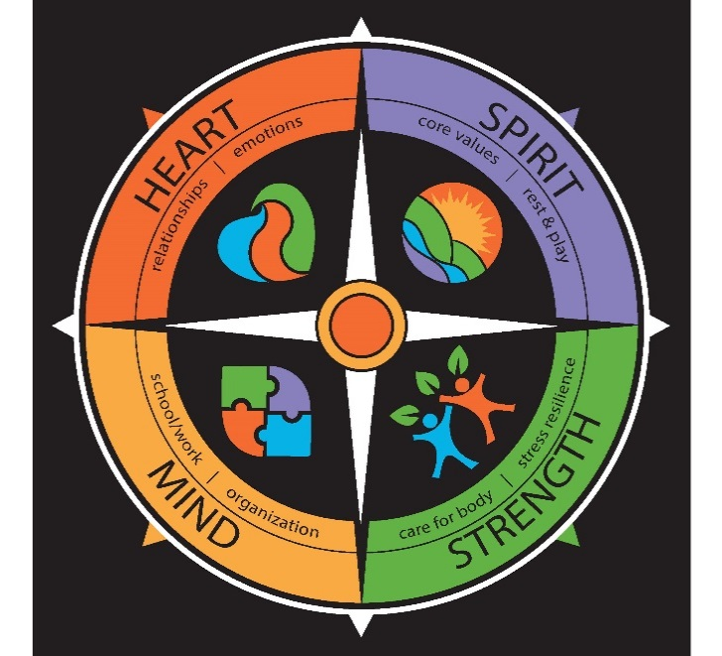

HEART
Relationships: the ability to create and maintain healthy connections with others in your life
Emotions: the ability to express your emotions and receive others’ emotions in a healthy way

MIND
School/Work: the ability to get the most out of educational, volunteer, and employment opportunities
Organization: the ability to manage time, priorities, money, and belongings

SPIRIT
Core Values: the development of a personal value system that supports your sense of meaning and purpose
Rest & Play: the ability to balance work and play to renew yourself
STRENGTH
Stress Resilience: the ability to deal positively with the challenges of life
Care for My Body: the ability to build healthy habits around your physical well-being, and to end unhealthy habits

 |  | What fatigue looks like in this area | What resilience looks like in this area
Heart | Relationships | Increased conflict in one or more of our important relationships, pulling away from others and failing to nurture important relationships | Having a variety of relationships, both personal and work-related, that are mutually satisfying and characterized by trust, integrity, honesty, commitment, and kindness.
Heart | Emotions | Chronically stuck in feelings of anxiety, sadness, or irritability. | Able to feel and express the full range of emotions in a healthy way.
Spirit | Core Values | Acting, living, or working in a way that are contrary to your core values | Living and working in alignment with our core values.
Spirit | Rest & Play | Being chronically tired and irritable from working too many hours and never being able to turn work off, even when not at work. | Engaging in activities that are truly re-creative of our bodies and our spirits, those activities that rejuvenate us
Strength | Stress Resilience | Facing stress alone, isolating from others. Reacting to stress rather than responding. | Able to ask for help from others and to create emotional space and perspective where we can respond to our stress in ways that are productive.
Strength | Care for Body | Literal physical fatigue. Our bodies will always tell the truth about how we are treating them. | Increased vitality and energy. Having a basic and consistent practice of caring for our physical wellness.
Mind | School/Work | Doing work that we do not feel makes good use of our gifts and talents, or because work has taken over our personal lives and we find ourselves feeling resentful toward our work. | Doing work that is meaningful and that fully uses our gifts and talents. It also comes from being able to find a balance between our work and our personal life.
Mind | Organization | Any of the following ways: being chronically late for appointments, forgetting to pay bills, forgetting or being late for assignments, and having an excessively messy work or home environment | Being well organized in regard to our time, money, environment, and priorities. Not overcommitting or over-scheduling, following through on plans and assignments.
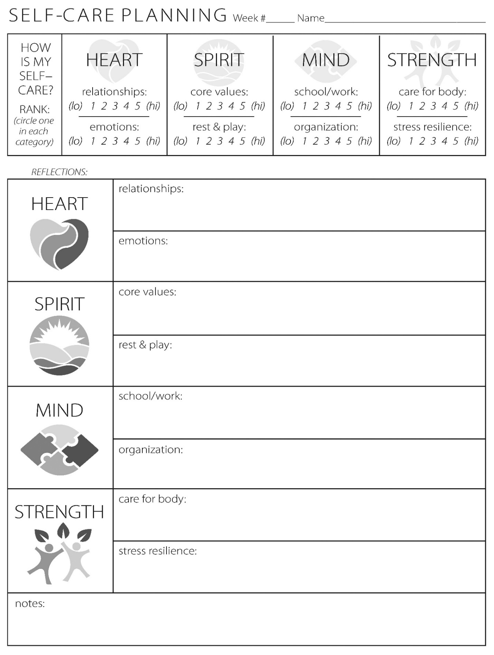
After reviewing what fatigue and resilience might look like in each area of the Wellness Compass, rate your wellness in each area. 1 represents fatigue and 5 represents resilience. Use the open spaces next to the eight areas of the Wellness Compass to write your reflections on this question: If and how does your score in each area of wellness impact your ability to be compassion resilient.
MIND Activity: Appreciative Inquiry Reflection on Competence

These questions can be used for individual reflection and/or conversations and planning in small teams.

1. Considering your entire time as a staff member at your school district, can you recall a time when you felt most alive, most involved, or most excited about your involvement in the district?
· What made it an exciting experience? What gave it energy?
· What was it about you — unique qualities you have – that contributed to the exchange?
· Who were the most significant others? Why were they significant?
· What were the most important factors in your school that helped to make it a meaningful experience (e.g. leadership qualities, structure, rewards, systems, skills, strategy, relationships)?
2. Let’s consider for a moment the things you value deeply. Specifically, the things you value about 1) yourself; 2) the nature of your work; and 3) Your school district
· Without being humble, what do you value the most about yourself – as a human being, a friend, a parent, a citizen, and son/daughter?
· When you are feeling best about your work, what do you value about the task itself?
· What is it about your school that you value?
· What is the single most important thing the school has contributed to your life?
3. Your school district seeks to build on “proven strengths” and has been a pioneer in a number of areas. In your opinion, what is the most important achievement that you can recall that best illustrates this spirit of “being the best”?
4. Can you think of a time when there was an extraordinary display of cooperation between diverse individuals or groups at your school?
· What made such cooperation possible (e.g. planning methods used, communication systems or process, leadership qualities, incentives for cooperation, skills, team development techniques)?
· How could these lessons be applied to your team/staff?
5. In your mind, what is the common mission or purpose that unites everyone on the team/staff? How can this continue to be nurtured?
6. What is the core factor that gives vitality and life to your school?
7. If you could develop or transform your school in any way you wished, what three things would you do to heighten its vitality and overall health?
· How could these three things be brought to the Leadership Team?

HEART Activity: Wholly Mindful Videos and Reflections

Wholly Mindful blogger Jamie Lynn, local Wisconsin self-compassion expert, has two helpful videos explaining the zones of activation and self-compassion. We often find ourselves feeling overwhelmed and experiencing compassion fatigue when we are not compassionate to ourselves. After watching the videos, answer or discuss the questions below.
Compassion Resilience: Zones of activation (3:30min) https://www.youtube.com/watch?v=PgIz5Pee89g
Compassion Resilience: Self-Compassion (5min) https://www.youtube.com/watch?v=IFtwii8zoGk

What signs does your body give you mentally, physically, emotionally when you are becoming overwhelmed when practicing compassion?
What are some ways you can help move yourself back into your comfort zone when you notice you’ve become overwhelmed?
SPIRIT Activity: Developing Your Professional Mission Statement
Contemplating and articulating our personal and professional mission can bring awareness to what drives us and allow for intentionality in our life and specifically, in our work. If our sense of purpose is an unconscious motivator of our thoughts, feelings and behaviors, it can complicate our ability to act competently, with self-awareness. Job satisfaction and compassion resilience are connected to being able to see that we are fulfilling our sense of purpose – our mission.

Begin by answering what, who, and how.
- What do you do?

- Who do you want to help? (Here would be a good place to brainstorm why you do what you do)

- How will you get your desired result?

My mission statement

Tips for your mission statement: use empowering and positive language. The goal is when you see your mission statement it renews you energy and sense of purpose in your work.
After you have written out your mission statement it takes intentionality to have this statement influence your daily work. Therefore, it may be helpful to select an object that you can associate with your mission statement. This could be simply your mission statement written out and placed on the wall, it could be a picture, a small desk figurine or toy-get creative! Make it personal and connect it to your mission statement. Then when you see that object, quote, or statement you will be reminded of why you are doing what you do and why it is worth it to continue.
*adapted from: https://www.adherecreative.com/blog/bid/138171/5-elements-of-a-powerful-company-mission-statement

STRENGTH Activity: Listening and Responding to Your Body’s Stress Alarm
Becoming aware of the signs your body gives is one of the steps in becoming stress resilient. Take the time to reflect on what your body is signaling to you in times of stress.

- How does your body let you know that you are getting out of balance, heading into stress?
- Often we adjust our health habits in response to stress. What patterns do you notice in the following three areas of your health habits?
  - What do you notice about your eating habits when you are stressed?
  - What do you notice about your physical exercise habits when you are stressed?
  - How about your sleep pattern?
As you review your answers, identify:
- What responses to stress do you want to do more of to build your stress resilience?
- What responses would you like to change?
Now that you have a list of some of the signals your body sends to notify that you are stressed, you can:
  - Recognize them in the future sooner so you are able to respond in a healthy manner
- Develop a plan to address how you can adapt your lifestyle to be proactive with your stress resilience

